4/3/2020
Most of this week concerned discussing the CAD model that will need to be constructed for a 3D printed piece that will connect to a rotating Arduino motor. The following was determined:
We determined that our first priority would be working with the CAD models for the additional pieces we will need for the Arduino motors.
The piece we would like to 3D print must be compatible with the rotating motor. The first step to create a compatible piece is to first exam the Arduino motor piece that will be connected to the 3D printed piece. The following picture displays the connecting component of the Arduno motor:
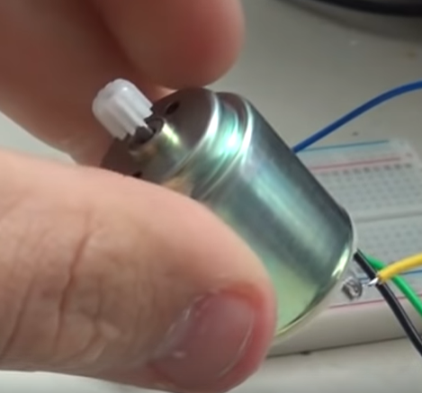

The white piece in the picture above rotates when a DC motor is connected to the motor. As is visible in the picture, the white piece has many edges, and a 3D printed piece can be constructed using CAD that accepts the white piece. Thus, a hole will be made that seals tightly around the white rotator.
The opposite end of the 3D printed piece needs to actually the rotate the valve on the sensor. To accomplish this, a hand will be made in CAD for the opposite end of the piece. This should firmly grip the sensor valve.

The team has planned to get the CAD model done in the near future.

